

**FINAL YEAR PROJECT:1**

***Project Title***

***University Sports Management Application***

-

* ***GROUP MEMBERS***

***1)Muhammad Aliyan Siddiqui 13300***

***2)Naveed Ahmed Siddiqui***

***3)Bilal Ahmed***

***4)SHUMAILA***

**TABLE OF CONTENTS**

|  |  |  |
| --- | --- | --- |
| **S. No** | **Topic** | **Page no** |
| **1** | **Project Name** | **1** |
| **2** | **Group info** | **1** |
| **3** | **Requirements** | **3** |
| **4** | **Use Case& User stories** | **5** |
| **5** | **Data Flow Diagram (DFD)** | **12** |
| **6** | **Entity relation Diagram (ERD)** | **16** |
| **7** | **State Diagram** | **18** |
| **8** | **Prototype** | **19** |

## **Requirements Analysis**

### **3.1 Detailed analysis of functional and non-functional requirements**

#### **Functional Requirements**

**Registration**

Users/students must register with an email address and receive a confirmation code to access the platform securely. Implement a twofactor authentication (2FA) mechanism to enhance account security and prevent unauthorized access.

**Previous** **Events:**

User can view the information of date-wise past sports events and its campuses, and participating teams. Users can search and view historical data for analysis or reference. Allow users to filter and sort past events based on criteria such as sport type, date range, and location

**Sports Information:**

Maintain a comprehensive list of sports offered by the university, including rules, regulations, and equipment requirements for each sport. Provide a dynamic sports information database that can be updated by administrators to reflect any changes or additions to sports .

**User Management:**

The system allows participants to register for any sport event along with respective teams only once. For practice purpose the users can also register/fix the time slots for availing the sports facilities

**Sports Events Management:**

The app should have the capability to manage all sports events within the university, including tournaments, matches, games, and other sporting activities.

#### **Non-Functional Requirements**

**1)Performance:**

* The system should be able to handle new registrations per hour without performance degradation.
* Creating a new tournament should be completed within 10 to 20 seconds.

**2)Usability:**

* Design the interface to be user-friendly and easy to navigate for all types of users.
* Provide clear instructions and help guides for using the system’s features.

**3)Compliance:**

* Follow university policies and legal requirements regarding data storage and user privacy.
* Ensure all sports regulations and guidelines are followed.

**4.1 Use case diagram illustrating system interactions**

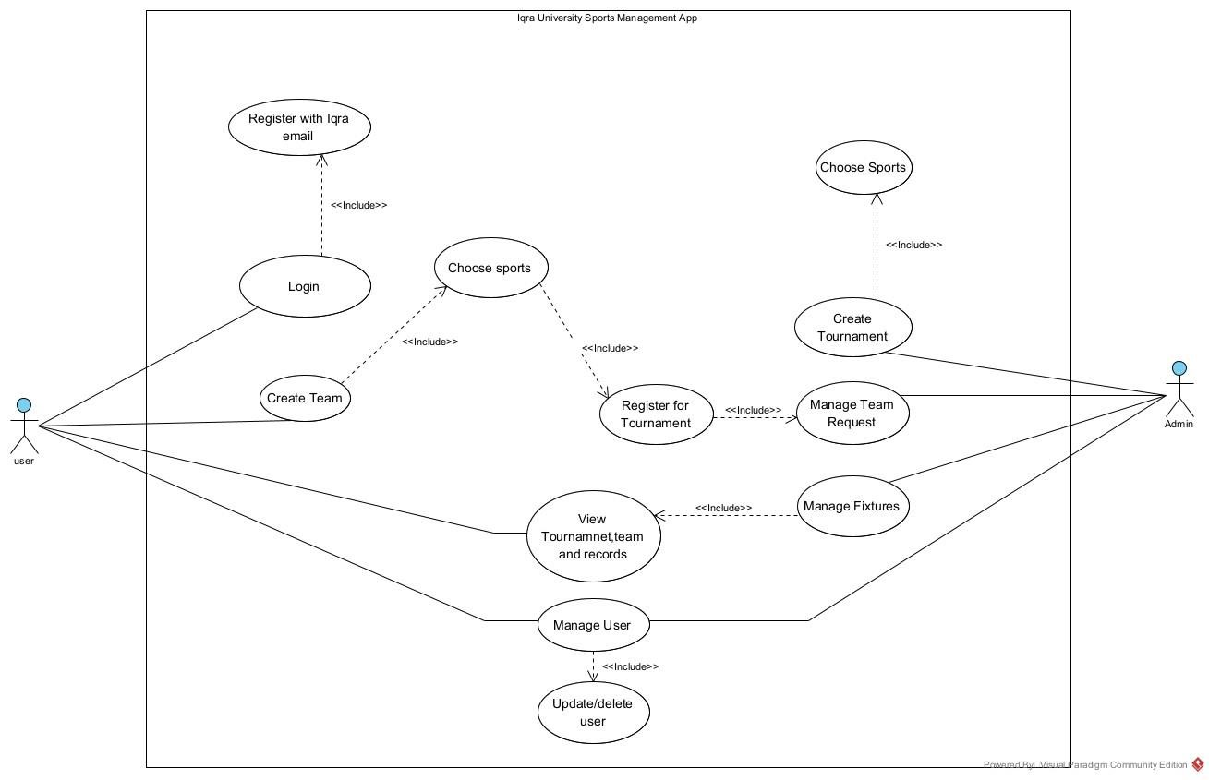

**4.1.1 User stories or scenarios**

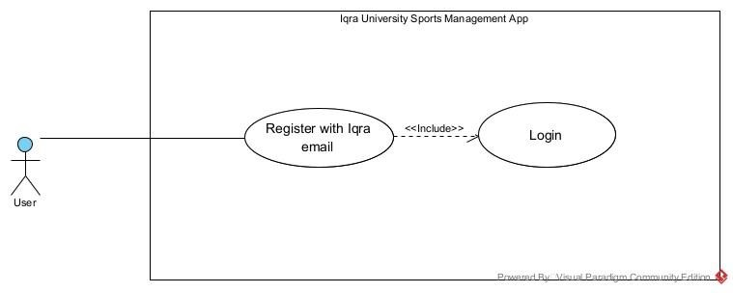

|  |  |  |  |
| --- | --- | --- | --- |
| **Use Case** | **Description** | | |
| Use Case Name  ID  Actors Involved Description  Pre-Conditions  Post-Conditions |  | Register and Login | |
| UC1 | |
| User | |
| User registers with their IQRA email address and logs in | |
| User has a valid IQRA email address | |
| User is registered and logged in to the system | |
| Flow Of Events |  | **Actor Action** | **System Response** |
| User enters IQRA email address and password | System validates email address |
| User submits registration form | System creates user account and logs user in |

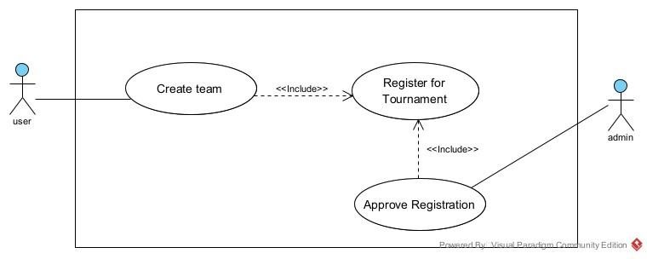

|  |  |  |  |
| --- | --- | --- | --- |
| **Use Case** | **Description** | | |
| Use Case Name  ID  Actors Involved  Description  Pre-Conditions  Post-Conditions |  | Create Team and Register for Tournament | |
| UC2 | |
| User,Admin | |
| User creates a new team and registers for a tournament, pending admin approval. | |
| User is logged in | |
| Team is created, and tournament registration is pending approval | |
| Flow Of Events |  | **Actor Action** | **System Response** |
| User: user enters team details (name, description, etc.) | System validates input, creates team |
| User: user selects tournament to register | Sends approval request to admin |
|  |  | Admin: Approves or rejects registration request | Updates tournament teams list |
|  |

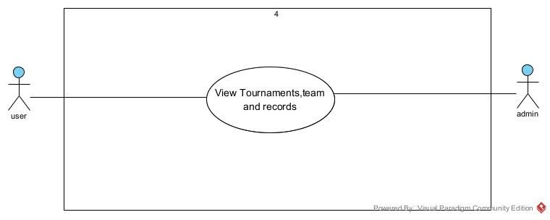

|  |  |  |  |
| --- | --- | --- | --- |
| **Use Case** | **Description** | | |
| Use Case Name  ID  Actors Involved  Description  Pre-Conditions  Post-Conditions |  | View Tournament Information | |
| UC3 | |
| User,Admin | |
| Admin or User views tournament details, team information, and previous records | |
| User or Admin is logged in | |
| User or Admin has viewed tournament details, team information, and previous records | |
| Flow Of Events |  | **Actor Action** | **System Response** |
| **User or Admin:** Selects tournament | Displays tournament details (name, description, etc.) |
| **User or Admin:** Views team information (team name, members, etc.) | Displays team details |
|  |  | **User or Admin:** Views previous records (tournament history,  results, etc.) | Displays previous records |

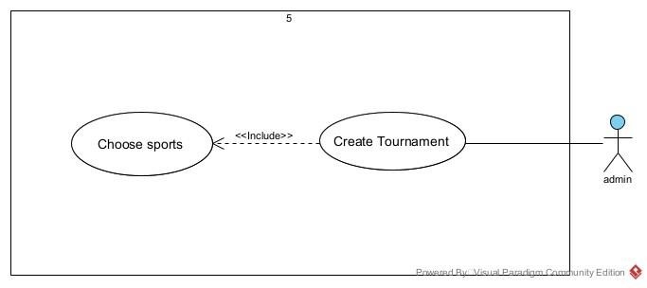

|  |  |  |  |
| --- | --- | --- | --- |
| **Use Case** | **Description** | | |
| Use Case Name  ID  Actors Involved Description  Pre-Conditions  Post-Conditions |  | Tournament Creation | |
| UC4 | |
| Admin | |
| Admin creates a new tournament | |
| none | |
| Tournament is created and visible to users | |
| Flow Of Events |  | **Actor Action** | **System Response** |
| **Admin**: Enters tournament details (name, date, etc.) | Validates input, creates tournament |

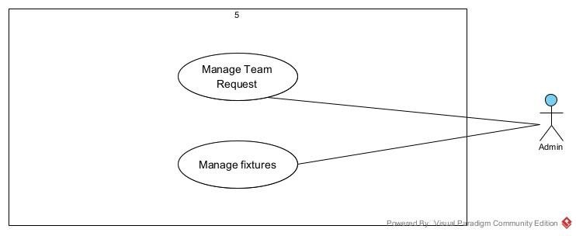

|  |  |  |  |
| --- | --- | --- | --- |
| **Use Case** | **Description** | | |
| Use Case Name  ID  Actors Involved  Description  Pre-Conditions  Post-Conditions |  | Manage Team Requests and Fixtures | |
| UC5 | |
| Admin | |
| Admin manages team registration requests, approves or rejects teams, and schedules fixtures. | |
| Admin is logged in | |
| Team requests are processed, and fixtures are scheduled | |
| Flow Of Events |  | **Actor Action** | **System Response** |
| **Admin:** Views team registration requests | Displays list of requests |
|  |  | **Admin:**  Approves or rejects team requests | Updates team status |
|  |  | **Admin:**  Schedules fixtures (matches, dates, times, etc.) | Updates fixture list |

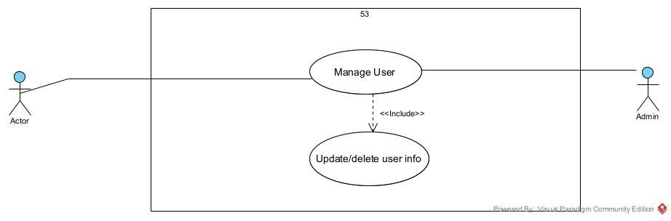

|  |  |  |  |
| --- | --- | --- | --- |
| **Use Case** | **Description** | | |
| Use Case Name  ID  Actors Involved  Description  Pre-Conditions  Post-Conditions |  | Manage User Profile | |
| UC6 | |
| Admin,User | |
| User updates their profile information, and Admin can update or delete user profiles. | |
| User or Admin is logged in | |
| User profile is updated, or user profile is deleted (by Admin only) | |
| Flow Of Events |  | **Actor Action** | **System Response** |
| **User:** Updates profile information (e.g., name, email, etc.) | Updates user profile |
|  |  | **Admin:** Updates user profile (e.g., to correct information) | Updates user profile |
|  |  | **Admin:** Deletes user profile (if user breaks rules) | Updates user profile |

# 

**5.Design Phase**

## **5.1) Data Flow Diagram Level 1**

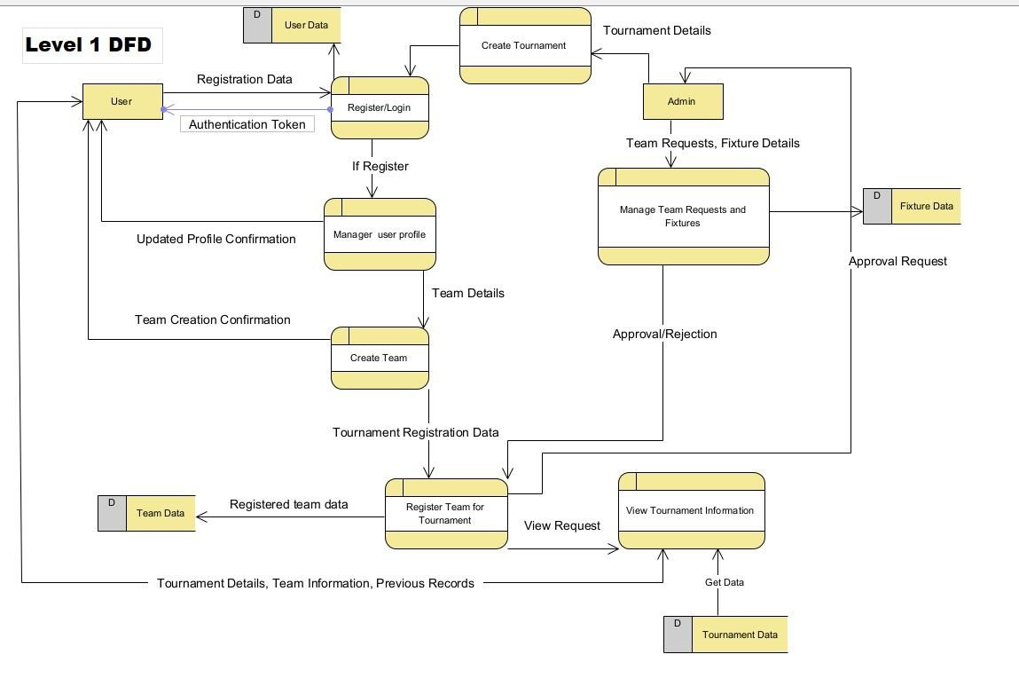

## **Data Flow Diagram Level 2**

# **Data Flow Diagram Level 2 User**

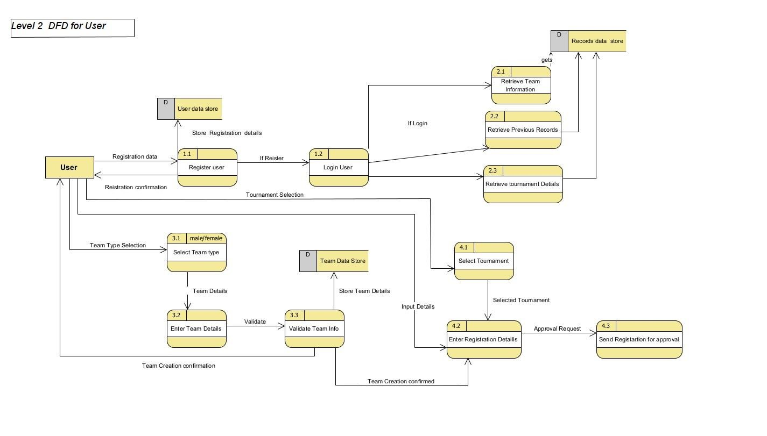

**1)Register/Login (1.0)**:

Handles user registration and login. Preconditions: Valid reg_id & email. Postconditions: User registered and logged in.

* **Register User (1.1)**: Validates registration details. Post condition: Details validated.
* **Login User (1.2)**: Authenticates user. Postconditions: User authenticated.

**2)View Tournament Information (2.0)**:

* **Description:** Allows users and admins to view tournament details, team information, and previous records.
* **Preconditions:** User or Admin is logged in.
* **Postconditions:** Tournament details, team information, and previous records are displayed.

**3)Create Team (3.0)**: Allows users to create teams. Preconditions: Logged in. Postconditions: Team created and stored.

* **Select Team Type (3.1)**: Selects team gender. Post condition: Gender selected.
* **Input Team Details (3.2)**: Inputs team details. Postcondition: Details inputted.
* **Validate Team Details (3.3)**: Validates details. Postcondition: Details validated.

**4)Register Team for Tournament (4.0)**: .

* **Description:** Handles the registration of teams for tournaments.
* **Preconditions:** User has created a team and is logged in.
* **Postconditions:** Team is registered for the tournament, pending admin approval.

# **Data Flow Diagram Level 2 Admin**

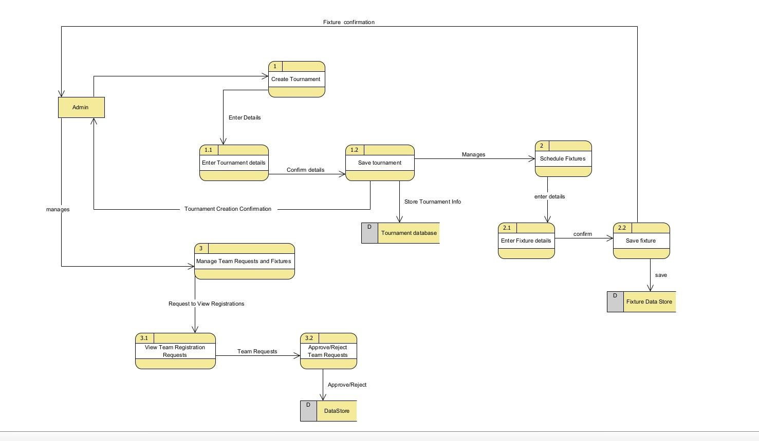

• **Create Tournament (1.0)**:

• **Description:** Allows admins to create new tournaments.

• **Preconditions:** Admin is logged in.

• **Postconditions:** Tournament is created and visible to users.

• They input tournament details (1.1) and save the tournament (1.2), making it visible to users.

• **Schedule Fixtures (2.0)**:

* **Description:** Admins schedule fixtures for tournaments.
* **Preconditions:** Admin is logged in and tournaments exist.
* **Postconditions:** Fixtures are scheduled and stored in the system.

• They input fixture details and confirm the schedule, ensuring it is stored in the system.

• **Manage Team Requests (3.0)**:

* **Description:** Admins manage team registration requests and schedule fixtures.
* **Preconditions:** Admin is logged in.
* **Postconditions:** Team requests are processed and fixtures are scheduled.

• **View Team Registration Requests (3.1)**: Admin views team registration requests.

•  **Approve/Reject Team Requests (3.2)**: Admin approves or rejects team requests.

**6. ENTITY RELATION DIAGRAM (ERD)**

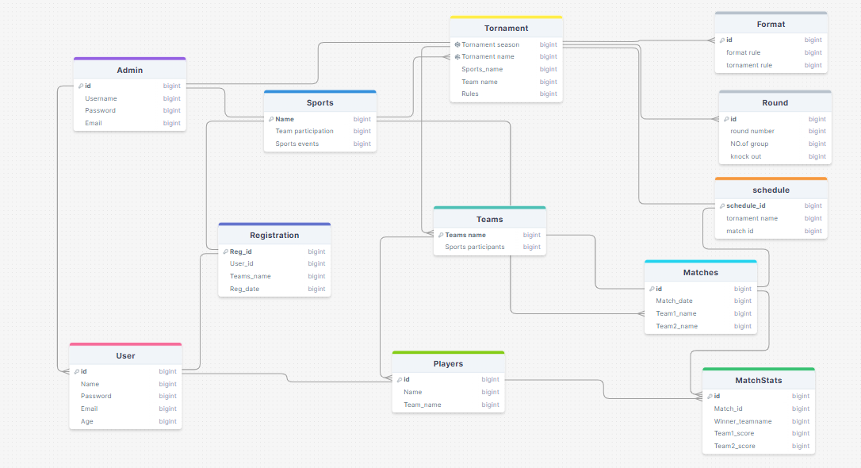

**Description of Entity Relation diagram**

1. **User**

Central entity that can either be a Player or an Admin.

1. **Admin**

Manages Tournaments and Schedules.

Manages multiple users.

1. **Playe**r

Manny players Part of a Team and participates in Matches.

1. **Registration**

Connects Users to sports.

1. **Sports**

Sports contain many tournaments with their teams.

1. **Teams**

Groups of team participating in Matches and Tournaments.

1. **Matche**s

Competitions between Teams, part of Tournaments.

1. **MatchStats**

Statistics of Matches, linked to Players and Teams.

1. **Tournament**

Tournament had specific format with their multiple matches

1. **Schedule**

Schedule connect tournament to matches.

1. **Format**

Format contains rules.

1. **Round**

Tornament has round which contain no.of group and knock out stages.

**7. STATE DIAGRAM :**

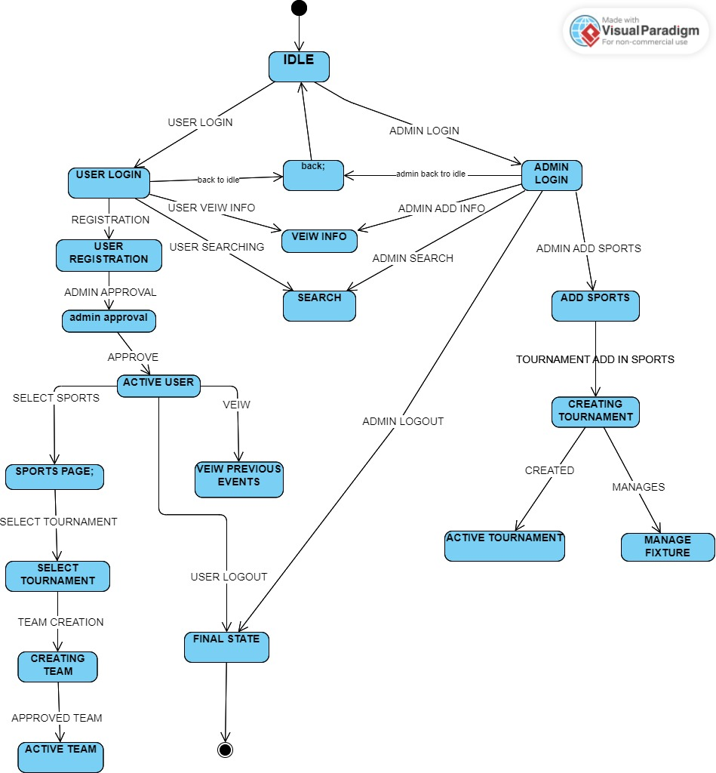

**8. User interface design: Mockups and wireframes.**

|  |  |
| --- | --- |
| **Figure 1**  **Start page** | **Figure 2**  **Sign-up login page** |
|  |  |

|  |  |
| --- | --- |
| **Figure 3**  **VEIW page** | **Figure 4**  **Sportspage** |

|  |  |
| --- | --- |
| **Figure 5**  **Sports page** | **Figure 6**  **Registration page** |